**STRICTLY EMBARGOED until 10am, Tuesday 8 October 2019**

**Explaining Voter Volatility: A summary of the British Election Study**

The British Election Study has identified the largest amount of electoral volatility in modern times. This has large consequences for the current political moment when an “electoral shock” – Brexit – is still playing out in this volatile electoral context.

The findings offer a new framework in which to view any upcoming general election. The analysis will be published in *Electoral Shocks: The Volatile Voter in a Turbulent World* (Fieldhouse et al., Oxford University Press, December 2019).

The BES is the longest running social science survey in the UK, and is funded by the Economic and Social Research Council. A representative ‘gold standard’ survey has been conducted after every general election since 1964, with many respondents interviewed in the subsequent election, providing unique insight into patterns of vote switching. The BES also now includes a 30,000-person online panel study which follows many of the same individuals over this unique period in British politics. The analyses are unique in-depth academic investigations into vote switching, and its reasons.

**Voter volatility**

In terms of individual vote switching, the 2015 and 2017 general elections were the most volatile we have seen in modern times. In 2015, 43% of people voted for a different party than in 2010, and there was the highest share of the vote on record for parties other than the big three. By contrast, in 2017, we saw the highest two-party share since 1970. 33% of people changed their vote from 2015, and there was the largest switch of voters from Labour to Conservative and Conservative to Labour recorded in BES data. Across the three elections, 2010/15/17, 49% of people, almost half, did not vote for the same party each time.

**Why is this happening?**

There is a long-term trend of partisan dealignment (weakening party identification) amongst voters. This means they are more susceptible to changing their vote between elections. New cohorts of voters are less partisan than those they are replacing.

Voters have also had more choice as smaller parties have broken through via local and European elections. These smaller parties find it far more difficult to hold onto their vote, so as these parties become more important, they increase the volatility in the electorate.

However, these factors alone do not explain the rise in volatility we have seen.

‘Electoral shocks’ over recent years offer an over-arching explanation for the unpredictability we have witnessed, and the parties that have benefited from it, from the surge in minor party votes in 2015, to the surge in two-party share in 2017. Furthermore, the impact of the shocks has been amplified by volatility, as unattached voters are more easily moved by the force of the shock.

**What is an electoral shock?**

1. An abrupt change to the status quo, significant and unanticipated.
2. Highly salient, noticed by those not interested in politics. They can’t be ignored.
3. Politically relevant, affect how parties are perceived and have the potential to reshape the party system.

We identified five shocks to the electorate over this period which have had a remarkable impact on election outcomes.

**Immigration and the rise of UKIP**

This began in 2004 when the Blair government decided to allow immigration from the EU accession countries. This was a highly salient decision – through media coverage immigration was elevated as a concern for the electorate which has resonated in elections, particularly since 2010. It affected the public’s evaluation of each governments’ competence as they were unable to respond with policies to reduce numbers. This fuelled euroscepticism and allowed for the strengthening of the challenger party, UKIP. It drove David Cameron to offer a referendum in 2016.

**The 2008 economic crisis and the recession**

This was a long-lasting shock which reshaped politics over a prolonged period. It was highly salient as it affected the lived experience of the population, and after the initial bail out of the banks, it led to a major policy shift – austerity. The fallout from the banking crisis was clearly a shock for the 2010 election but it lasted through to 2015 with the public continuing to blame Labour. The Conservatives successfully kept questions of Labour’s economic competence to the fore. They won the argument that austerity was necessary because of Labour’s poor management of the economy. The old shock was used to score new political points. This shock illustrates that the fallout of economic crises can last for a long time. There are lessons here for a government which may oversee an economically damaging Brexit. By 2017 Brexit had usurped austerity as the main issue for voters.

**Lib Dems in coalition**

The decision for the Lib Dems to join the Conservatives in government in 2010 was still impacting in 2017, and meant their fortunes recovered very slowly. The Lib Dems lack strong core partisan support and they often borrow votes from Labour where they are the closest challenger to the Conservatives. Those left-leaning voters, who helped the Lib Dems to their success in 2010 felt let down, and it is taking many years for the party to regain their trust. It is also clear that a party, once weakened, enters a vicious cycle, if it doesn’t appear to be able to win, tactical voters won’t vote for it.

**Scotland’s two referendums**

The Scottish Independence referendum in 2014 altered political alignments in Scotland. This had a massive impact in the 2015 election as it cut across party allegiances. This led to the collapse of Scottish Labour and the emergence of the SNP as the third biggest party in the UK. 90% of Yes voters voted SNP in the 2015 election. The experience of the referendum meant party allegiances crystallised along independence lines. The position of voters on independence mattered more after the referendum than it had before, so Yes voters were no longer prepared to support pro-union Labour. This effect carried over into the 2017 election to a degree. However, by then the EU referendum had created a further disruption. The SNP lost ground to Labour and the Conservatives as Yes-Leave voters switched parties.

The Conservatives advanced in 2017 because they picked up support from across the board, particularly Yes-Leave voters, No-Leave voters. Two electoral shocks in three years rewrote the Scottish political landscape. The SNP went from third in 2010 to first. Labour went from first to third, and by 2017 the Conservatives had moved up to second.

**Brexit – 2017 election**

The result of the EU referendum was the biggest shock to British politics in decades. The 2017 election illustrated how Brexit is reshaping British electoral politics. This election saw the return of two-party politics with 82% of people voting for main parties. However, there was a restructuring of each party’s support with the largest number of people switching from Labour to Tory and vice versa than the BES has ever seen. 1 in 8 Conservative voters from 2015 switched to vote for Jeremy Corbyn. 1 in 11 went the other way and defected from Labour to the Conservatives. This amounted to 11% of the electorate switching between the largest parties, the highest level in BES data. When Tony Blair swept to power in 1997, the figure was 9%. Some old Labour seats fell to the Tories in 2017, while several affluent Conservatives seats were picked up by Labour. This was down to the electoral shock of Brexit. The parties made strategic choices which brought about substantial changes in where their votes would come from. The Conservatives decided to get behind Brexit and won UKIP’s Leave voters with their unambiguous message on controlling immigration. At the same time, Conservative Remain voters defected in large numbers, with 31% switching sides. Labour’s softer stance on Brexit attracted some Remain voters, while their shift to the left pulled Green voters to them. Despite backing Remain, the Lib Dems were still suffering in 2017 from the effects of the 2010 coalition.

In 2017, for the first time in modern history, non-economic attitudes including immigration and Europe were equally as important as left-right in sorting Conservative from Labour voters. This led to the emergence of two new key identifiers in the 2017 election – education and age. Labour became the party of the younger and highly educated voter, the Conservatives of older voters and those with fewer qualifications. This election has shown that when parties shift from running a traditional class based economic campaign to what we saw in 2017 – something two dimensional, like the EU and immigration – then it can lead to a rapid realignment. In this case it was around age and education, with class diminishing in importance. It remains to be seen whether this persists into a long-term realignment.

**Figures**

**Historic aggregate level volatility**

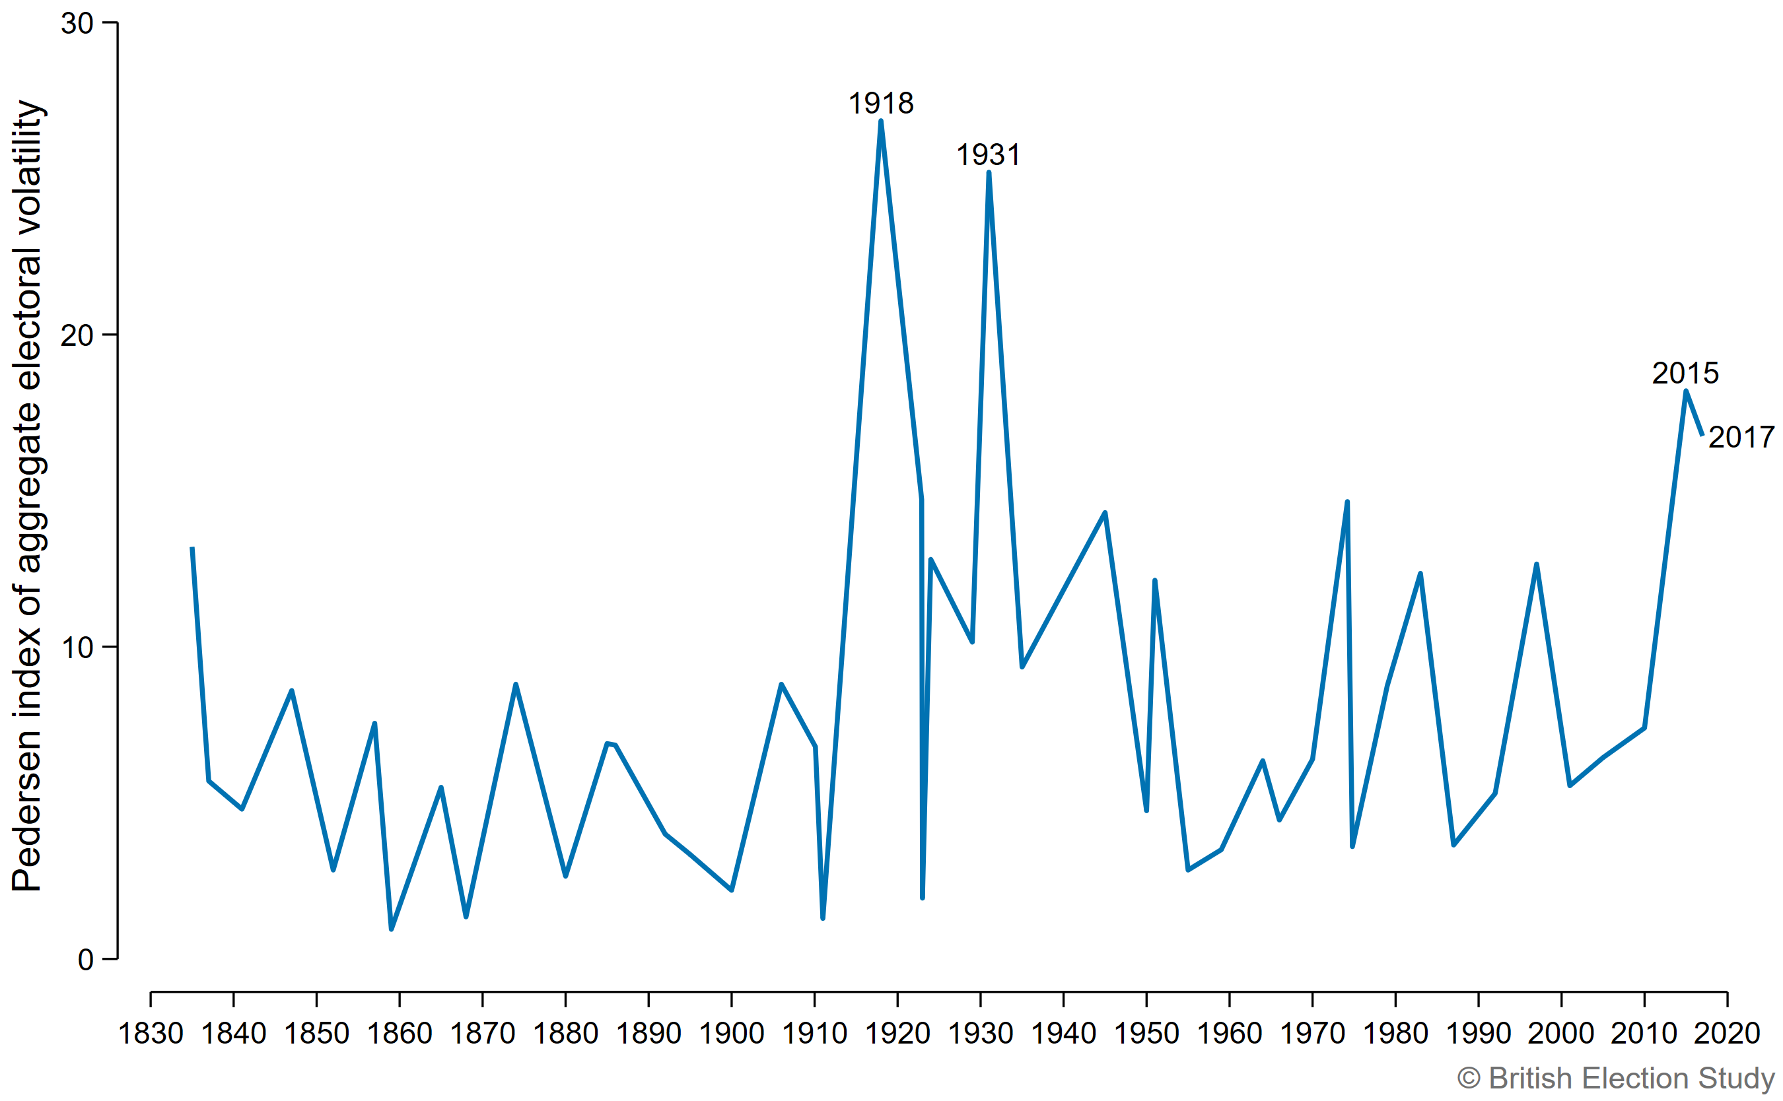

Aggregate level volatility measures how much the national vote share of parties has changed between elections (using ‘The Pedersen Index’). This graph puts 2015 and 2017 in historical context and shows how remarkable they were. Only two elections have had higher aggregate volatility. The first was the 1918 election which came at the end of the First World War and followed the expansion of the franchise to all men over the age of 21 and women over 30. The second was in 1931 following the Great Depression and a budget crisis. It was won by a National Government, formed at the request of the King, in a landslide. So 2015 and 2017 illustrated more aggregate volatility than the elections in 1945, 1979 and 1997.

**Individual-level voter volatility between elections recorded by the BES since 1964**

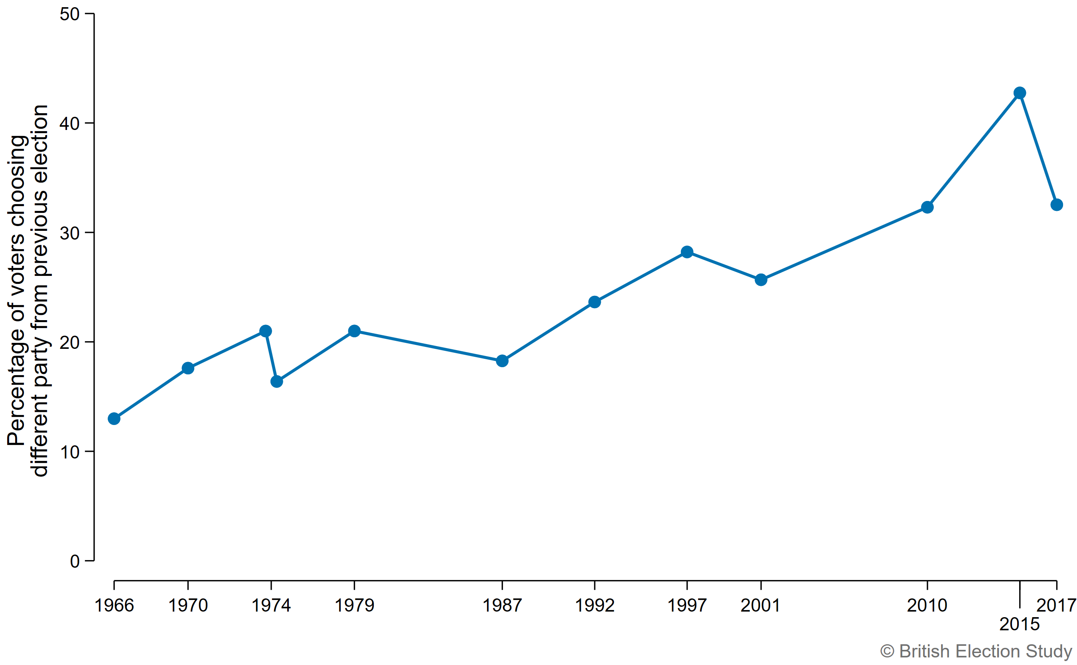

Individual-level volatility is the proportion of voters who switch to a different party in the second election of a pair.

The horizontal axis represents the second election in adjacent elections. The lowest level was at the start of the BES when 13% of voters switched in 1966. In contrast to the measure of aggregate level volatility, individual volatility has risen over time with voters becoming more likely to switch parties. The two measures do not match because in some elections, switching voters cancel each other out. For instance, 1966 and 2001 have similar levels of aggregate volatility but voters were twice as likely to switch parties by 2001. Using this measure, 2015 is a clear high point of individual volatility with 43% switching from 2010. The 2017 election is only slightly more stable but is still the second highest level of individual volatility in BES data.

**Vote flows between 2010 and 2015**

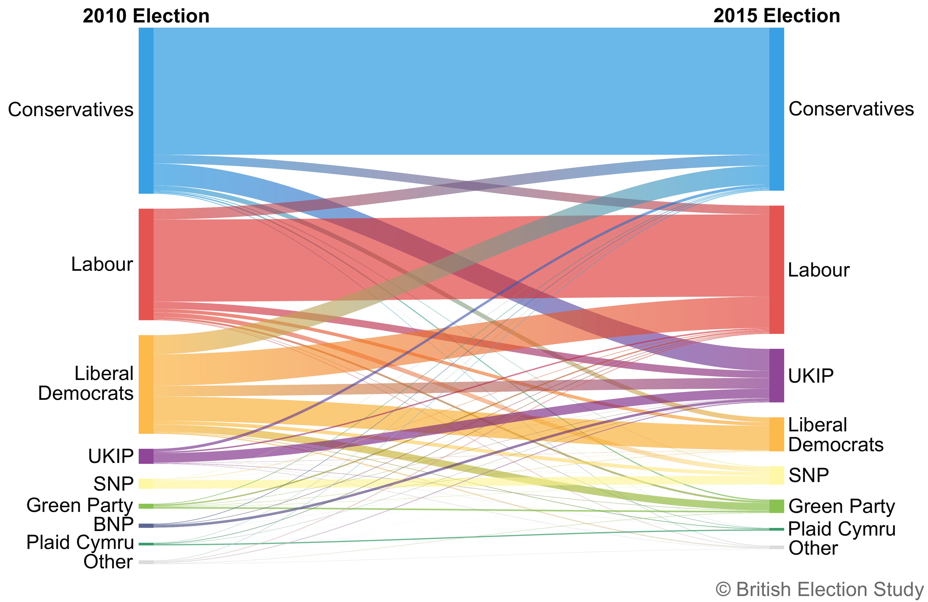

This shows how votes flowed between parties from 2010 to 2015. The size of the bar at either end of the ribbons (representing vote flow) is the total share of the vote each party received at the election. Note the dramatic way large scale switching manifested in 2015 in the collapse of the Lib Dem vote. They retained only 25% of their 2010 supporters and their losses were mostly to Labour, but also to other parties.

**Vote flows between 2015 and 2017**

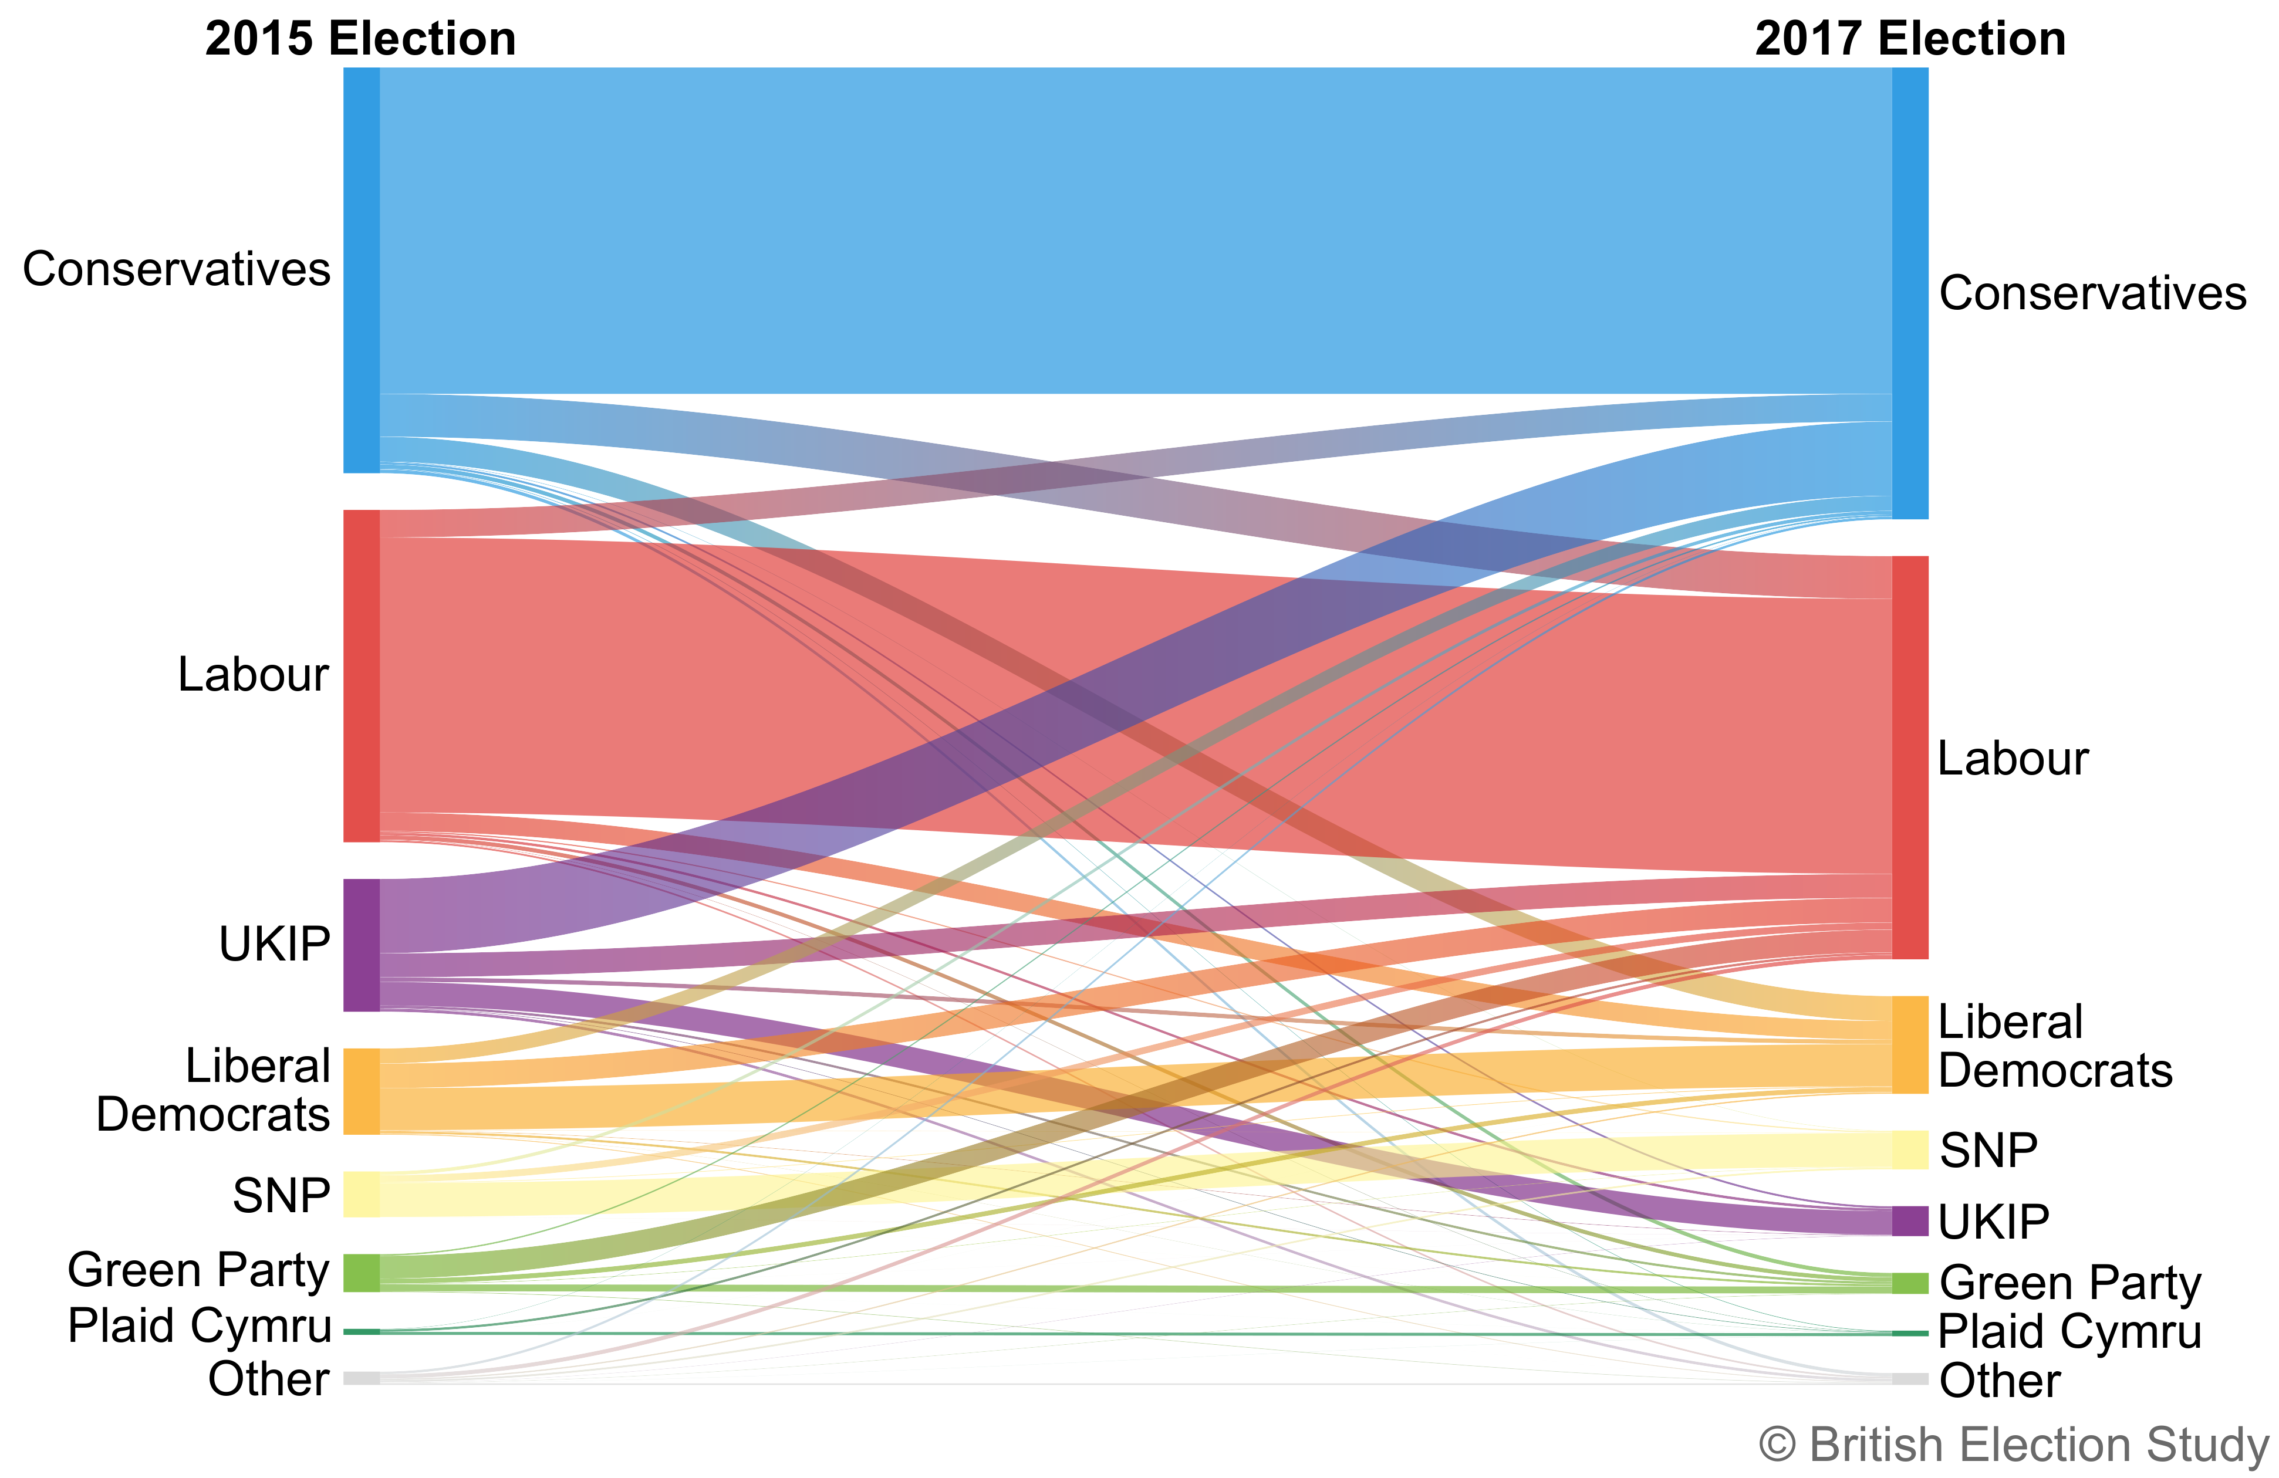

This shows how votes flowed between parties from 2015 to 2017. The size of the bar at either end of the ribbons (representing vote flow) is the total share of the vote each party received at the election. These changes were over only a two-year period and therefore switching would be expected to be lower than in a five-year cycle. However, 33% of BES respondents switched between these two elections including unusually high numbers from Labour to Conservative and vice versa (see figure below).

**Switching of voters between the Labour and Conservative parties**

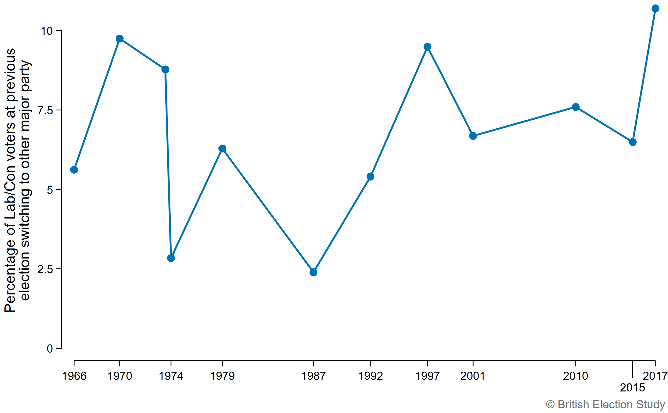

This graph shows the combined switching from Labour to the Conservatives and from the Conservatives to Labour between one election and the next, as a percentage of Labour and Conservative voters at the previous election. This is a more unusual kind of volatility. In 2017, a higher proportion of Labour and Conservative voters switched to the other major party than in any previous election we can compare. This contributed to surprising geographic spread of both votes – Conservatives winning Mansfield and Middlesbrough South, Labour winning Canterbury and Battersea.

**Where the Leave vote went in 2017**

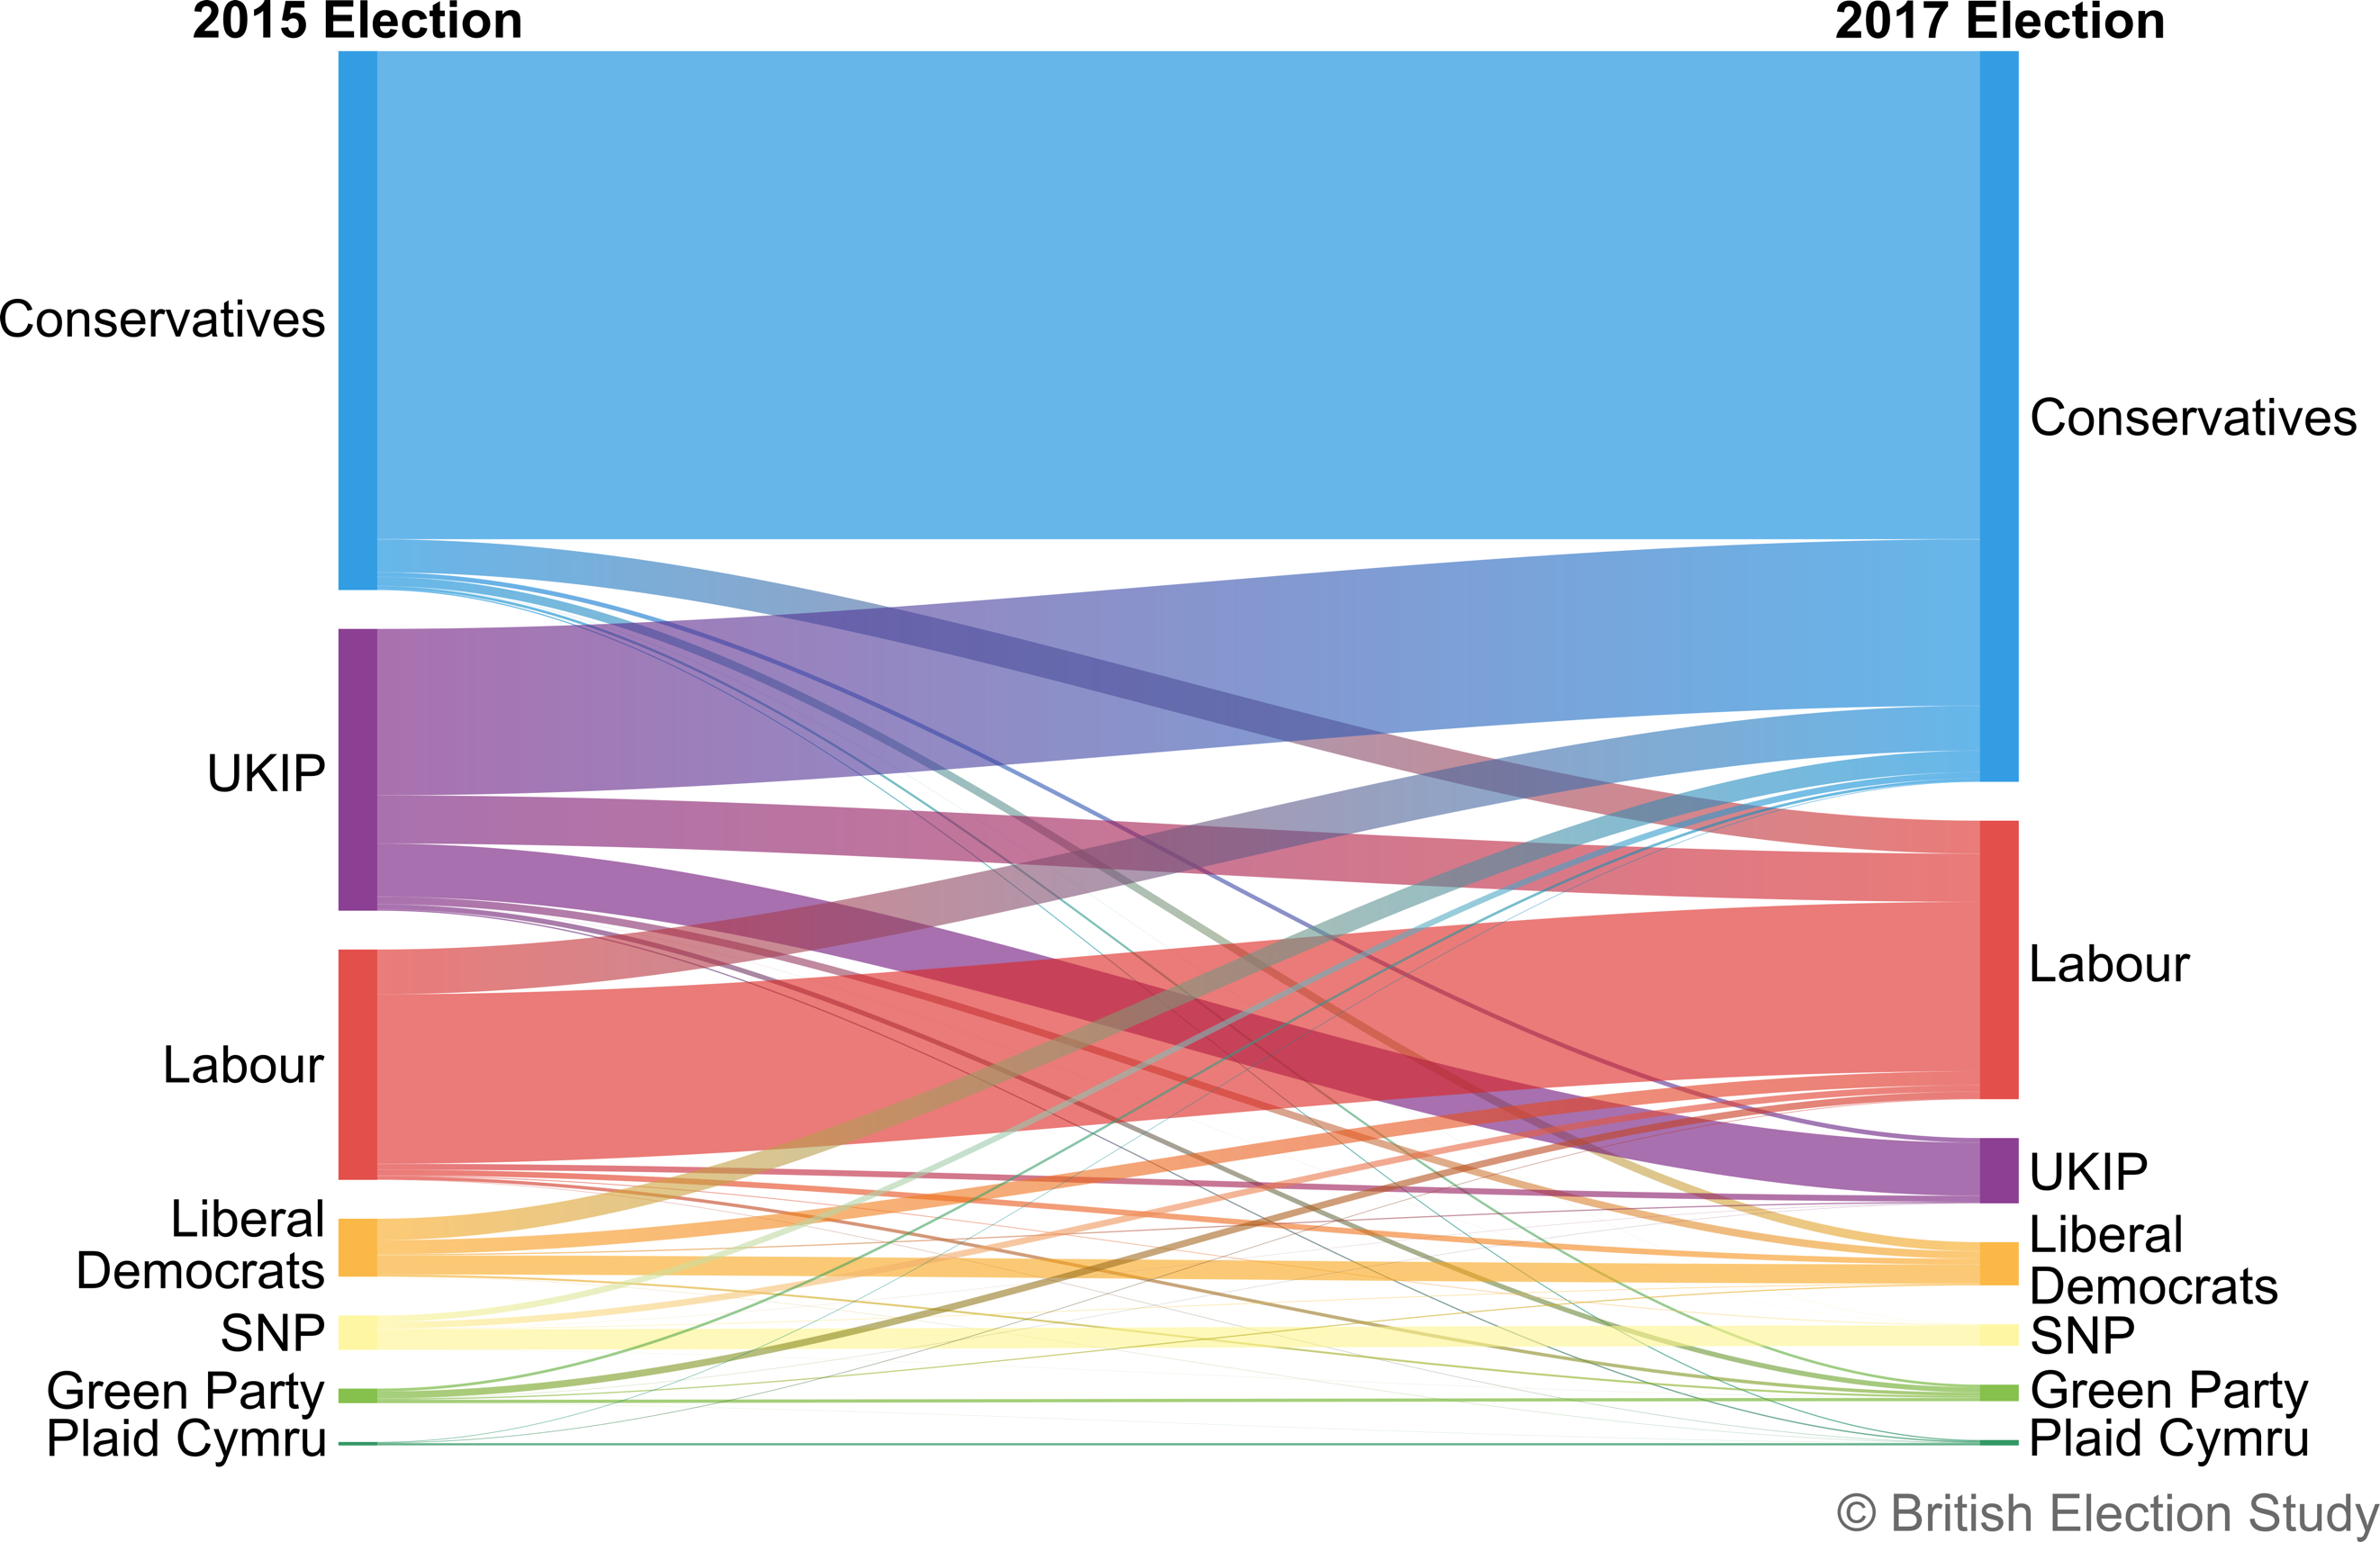

This chart shows where those who voted Leave in the referendum voted in 2017 compared to how they voted in 2015. The UKIP vote collapsed with more than half of their 2015 vote switching to the Conservatives. Labour lost more Leave voters to the Conservatives than they gained from UKIP.

**Where the Remain vote went 2017**

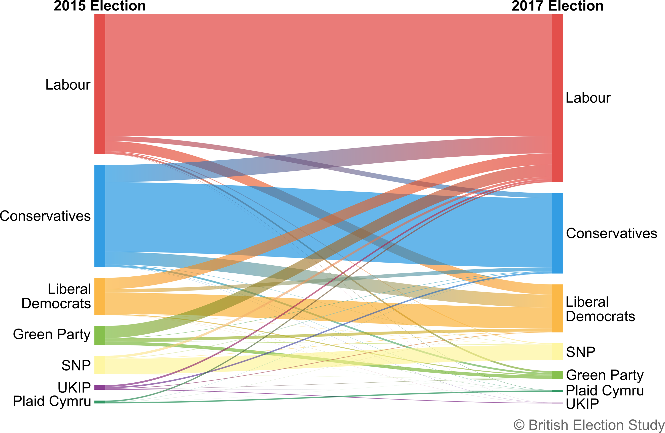

This chart shows where those who voted Remain in the referendum voted in 2017 compared to how they voted in 2015. The Conservatives lost Remain voters to the Lib Dems and Labour. Despite an ambiguous position on the single market, Labour was seen as the best bet for pro-EU voters. They won votes of Conservative Remainers along with pro-EU Greens and Lib Dems. Nearly 2/3 of 2015 Greens went to Labour, attracted by Jeremy Corbyn’s leadership.

**Implications for an upcoming election**

This election result cannot currently be predicted. There is uncertainty on too many levels. What the BES found in 2015 and 2017 together tells us that it is unwise for any political party (or commentator) to think they know how voters will behave in a general election in the middle of an electoral shock.

1. **There are likely to be more volatile voters**

The BES has shown that the historic trend is for voters to become less loyal (they switch their votes more across elections) as they have become less partisan. Younger voters are not inheriting the partisanship of their parents, and so this trend is difficult to reverse.

High vote shares for smaller parties in the European parliament elections will not easily translate into high vote shares in a general election, and small party voters are less loyal across general elections. The high Lab/Con share in 2017 might mean that the two large parties retain their voters, but there was also significant switching between these two largest parties in 2017, as previous loyalties were strained by Brexit.

High volatility of the Brexit Party vote implies high flux in Conservative vote. High volatility of Liberal Democrat and Green votes also implies high flux in the Labour vote.

We cannot predict yet whether Brexit identities will lead to greater stability, or whether a realignment along age/education lines will change volatility. Brexit identities imply that voters could stay loyal within Remain or Leave party groupings (Con/BXP v Lab v LD/SNP/Green/PC) for the time being, but how this splits is dependent on the success of campaigns and policies.

Party positions are shifting, so there is uncertainty for voters about which party it is best to back for Leavers and Remainers.

Volatile voters are more influenced by the campaign, so the higher the number of switchers, the greater the chance the campaign will affect how they vote.

1. **The ongoing Brexit shock will have a greater impact because of the more volatile electorate**

The Brexit shock has not run its course. The ramifications continue to play out and the long-term impact is not yet known. That will depend on the circumstances of our leaving and how our relationship with the EU is redrawn. What is clear is that the dramatic change seen between the 2015 and 2017 elections was not determined by traditional economic issues, but by the biggest political shock the country has experienced for many years – Brexit.

There are three ways that shocks shape public attitudes.

Competence – this is highly significant and its impact highly unpredictable. We don’t know who will get the blame for the political deadlock so far, the outcome we are dealing with by election day, or the fallout of that outcome – if there is any. We expect a major competence shock – if it happens – to be important and potentially long-lasting. The blame game is an important part of the transmission of competence shocks onto parties.

Salience – EU and immigration continue as critical issues for voters, and Brexit preferences help determine how people vote. The salience of Brexit also forces parties to be judged on Brexit. Age and education impact on Brexit preferences (as identified in 2017) and therefore how people may vote in 2019. Left-right continues to also be important, and shouldn’t be ignored in a focus that is only driven by Brexit.

Perceptions of party positions and party images – given the importance of Brexit to party competition, policy positions and perceptions of competence, a major change in position, emphasis or political alliance will have important consequences for how the parties are perceived and who they are seen to represent.

1. **The campaign**

The campaign has greater impact with greater numbers of volatile voters. Shocks – such as Brexit – create political opportunities for parties to compete around.

Campaigns are when voters are paying most attention and when political parties most visibly compete around shocks, leading to unknowns at this point ahead of a general election campaign.

In 2017, the traditional axis left/right was not completely supplanted by Brexit. Other policies and leader issues in the campaign could stop Brexit being the only factor.